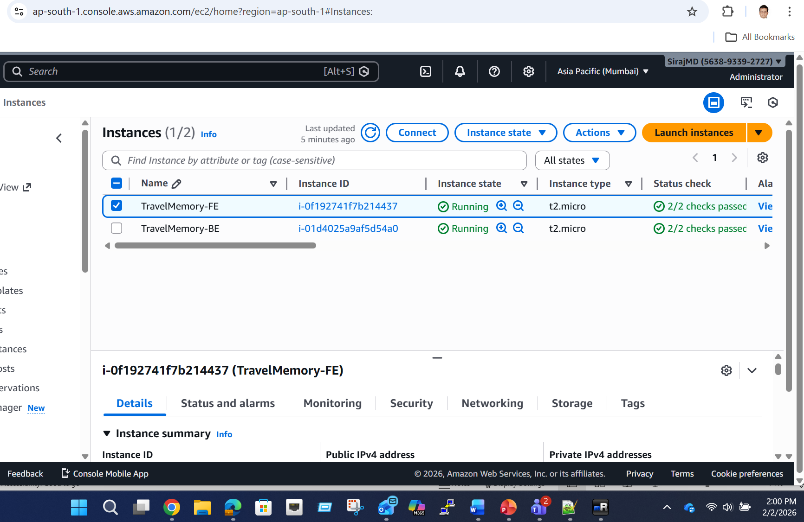

git clone https://github.com/UnpredictablePrashant/TravelMemory.git
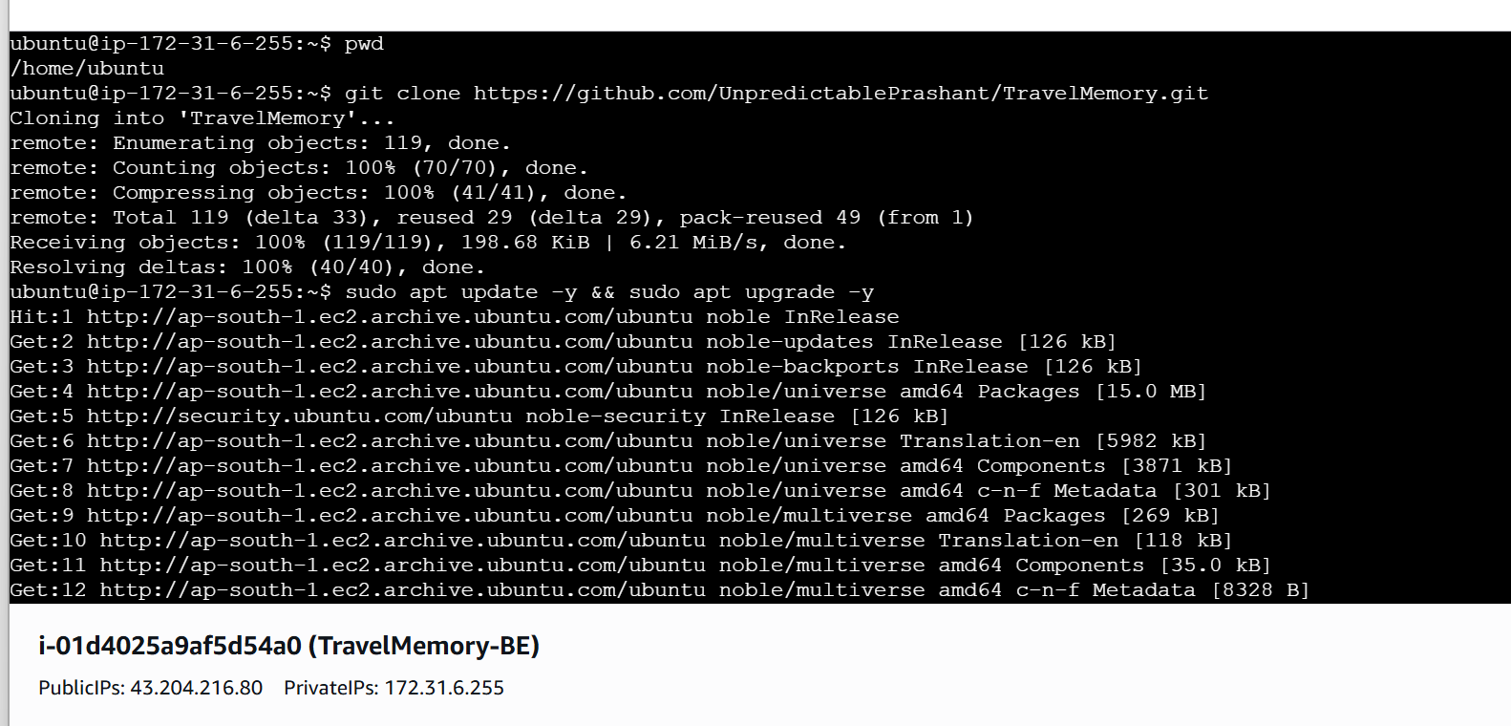

sudo apt update -y && sudo apt upgrade -y
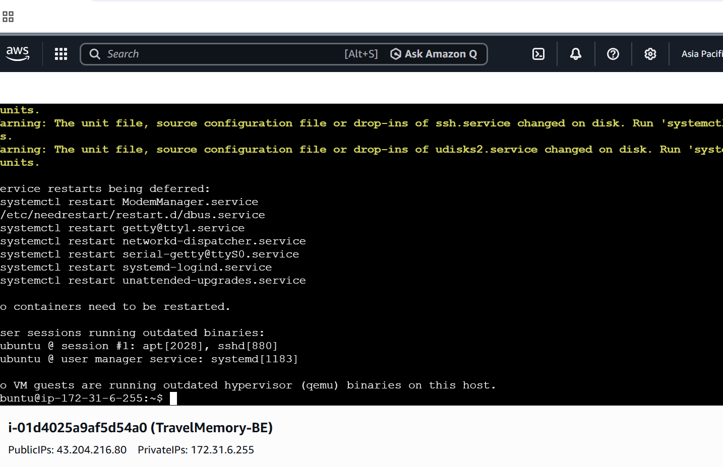

sudo apt install -y git nginx nodejs npm
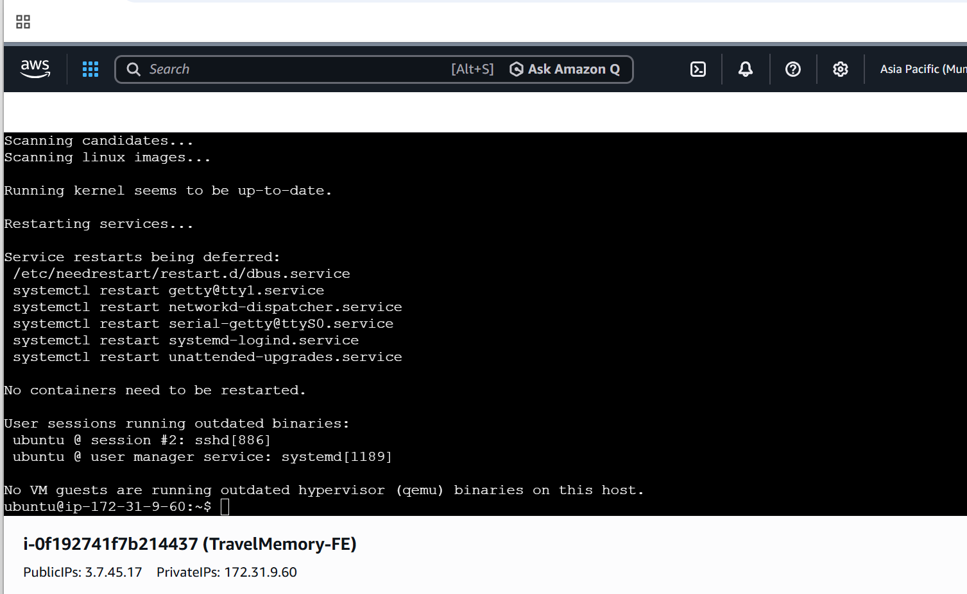

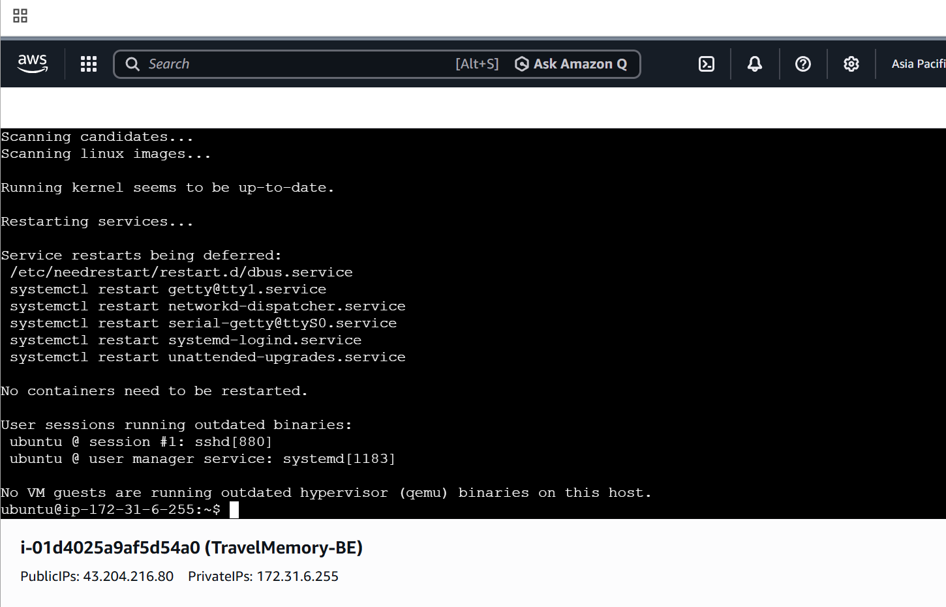

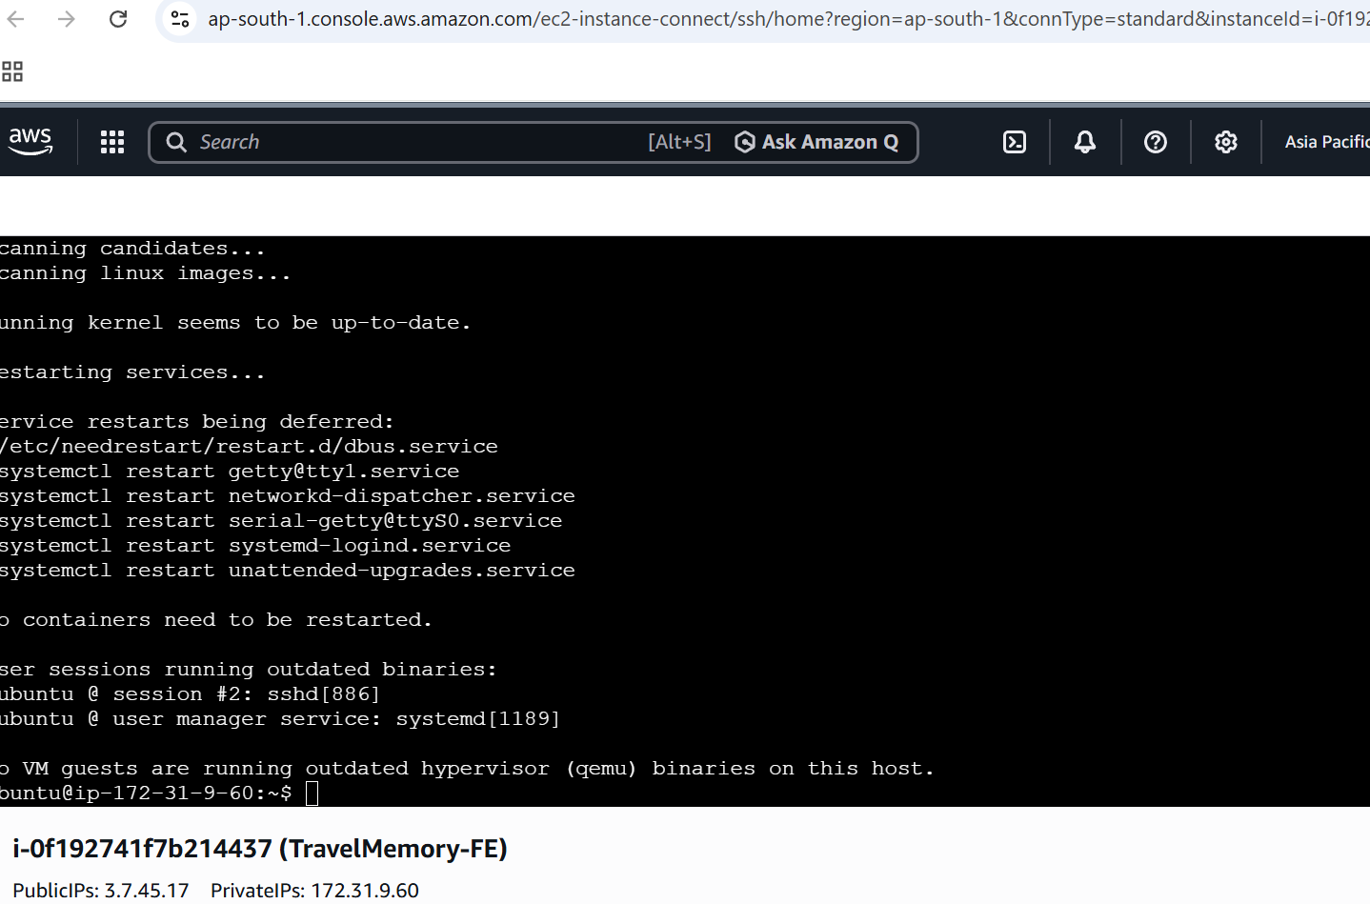
sudo npm install -g pm2
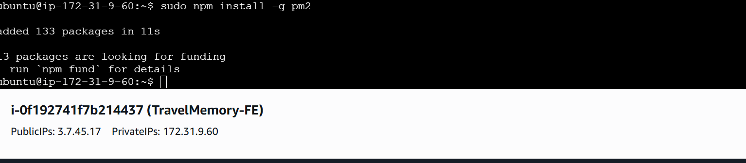

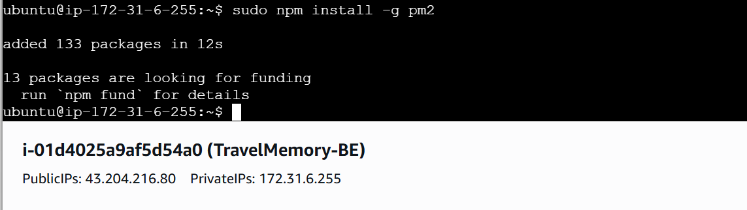

npm install
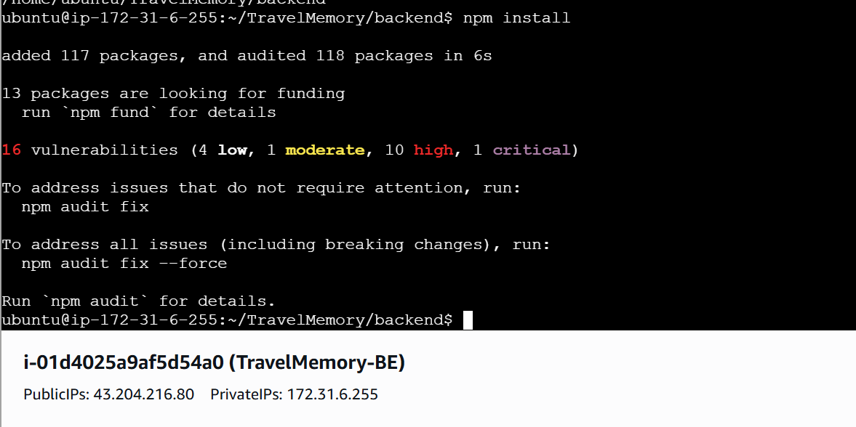

Configure Backend
cd TravelMemory/backend
npm install
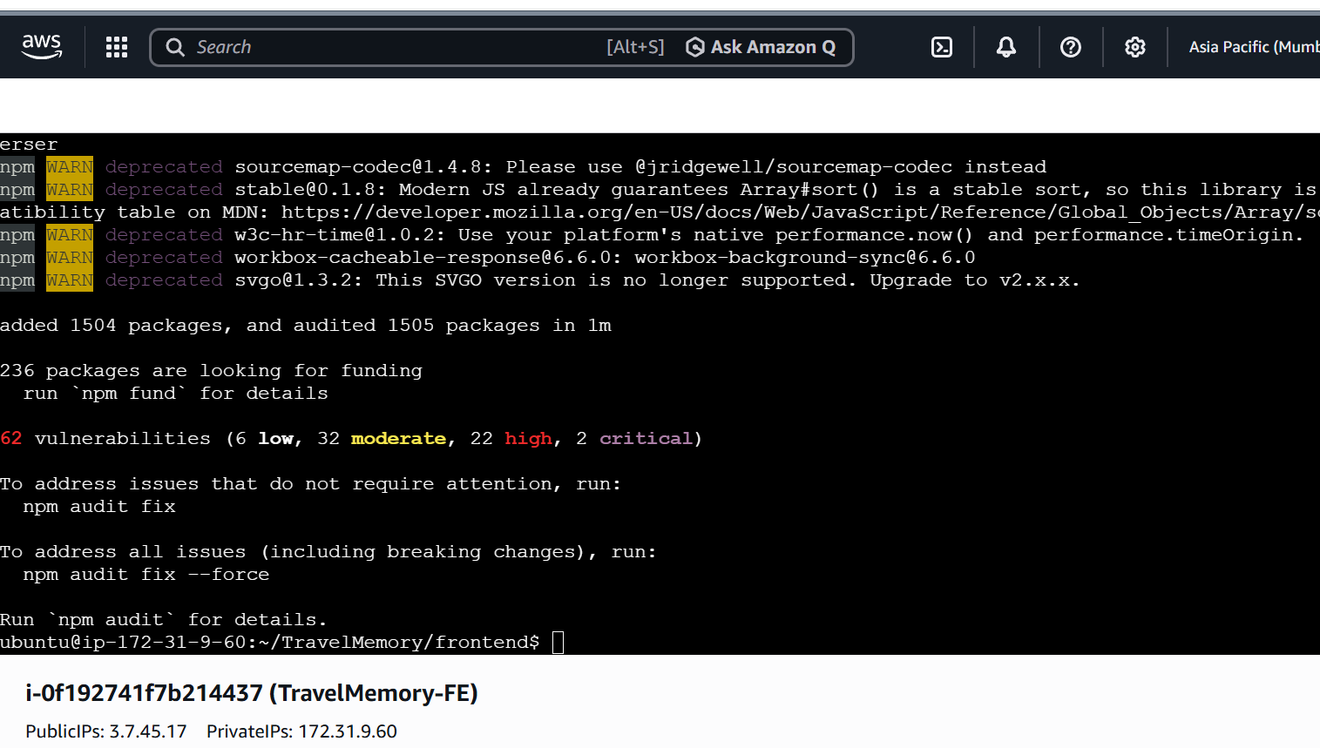
Done for backend server also
Create .env:
MONGO_URI="your-mongodb-atlas-url"
PORT=3000
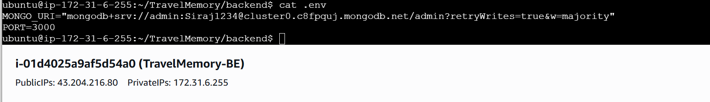

pm2 start index.js --name travelmemory-backend
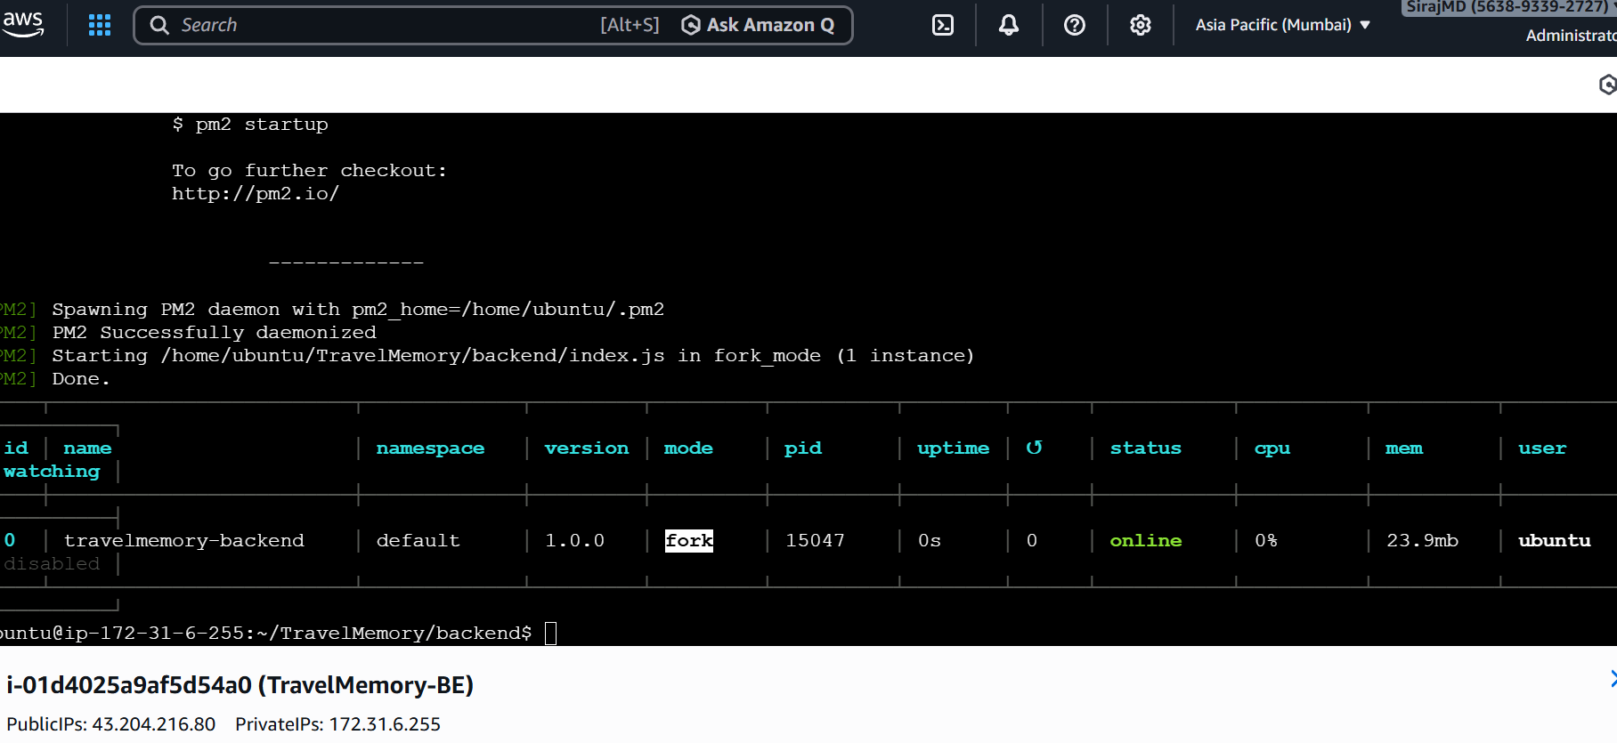
pm2 save
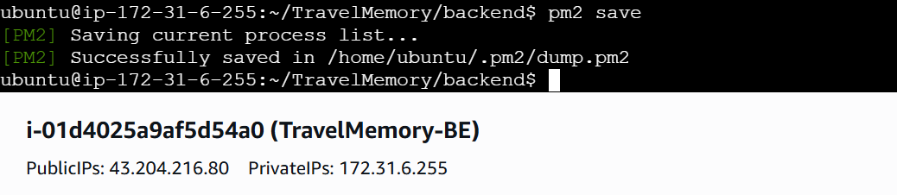
pm2 startup
sudo nano /etc/nginx/sites-available/default
server {
listen 80;
server_name _;

location / {
proxy_pass http://10.214.16.1:3000;
proxy_http_version 1.1;
proxy_set_header Host $host;
proxy_set_header Upgrade $http_upgrade;
proxy_set_header Connection 'upgrade';
proxy_cache_bypass $http_upgrade;
}
}

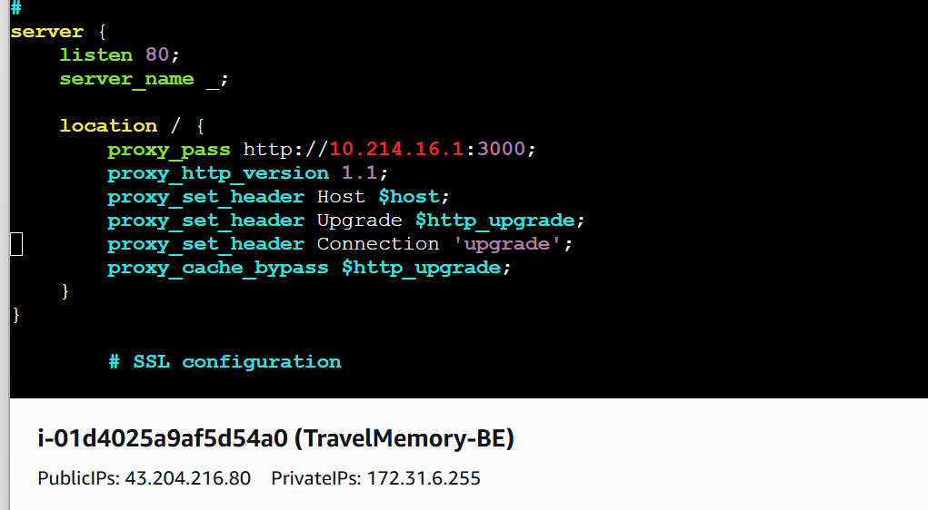

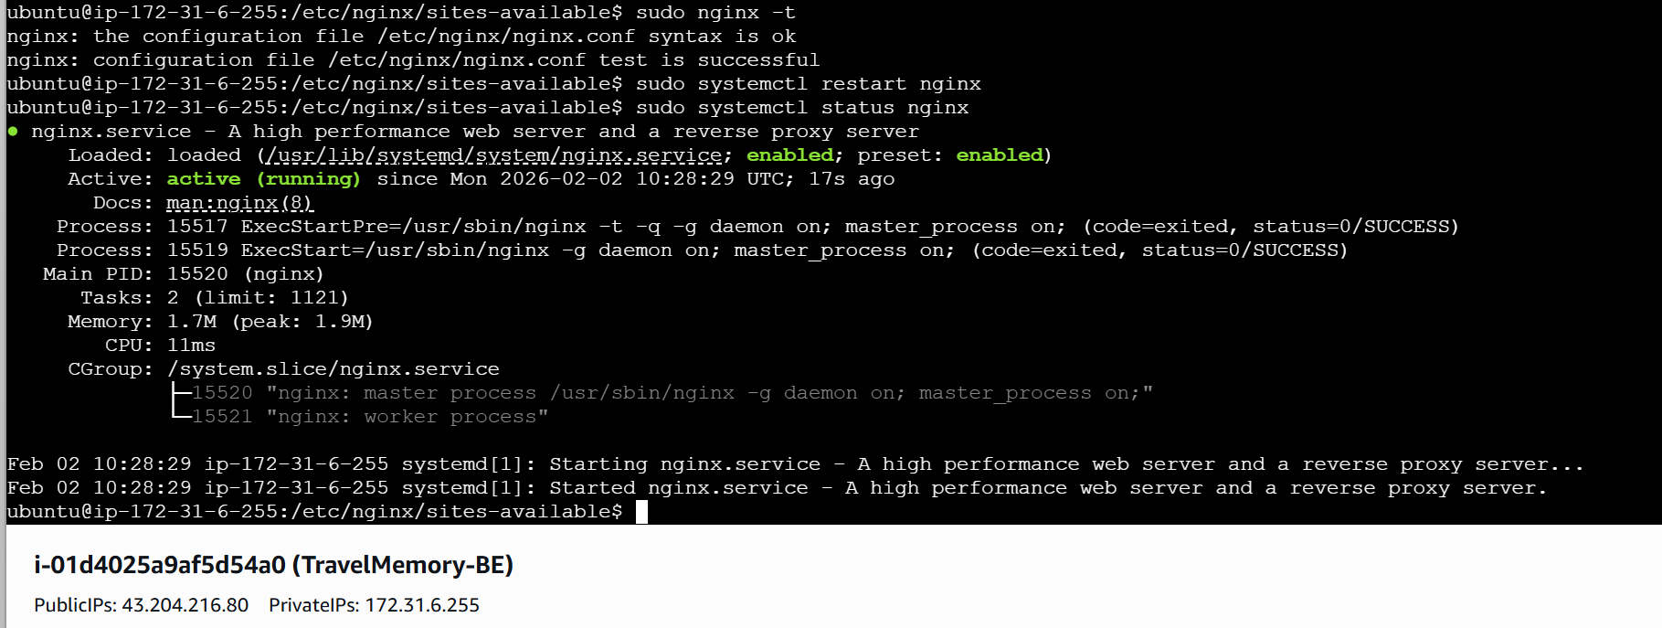
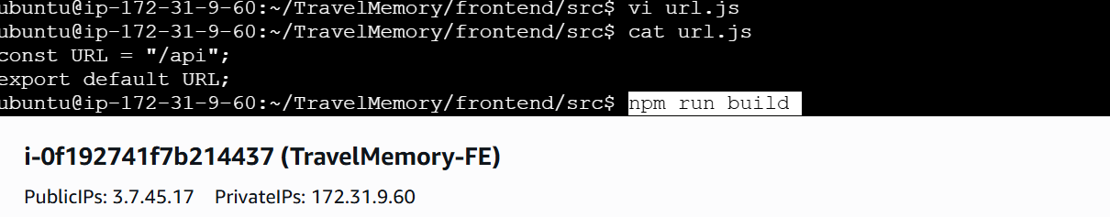

npm run build

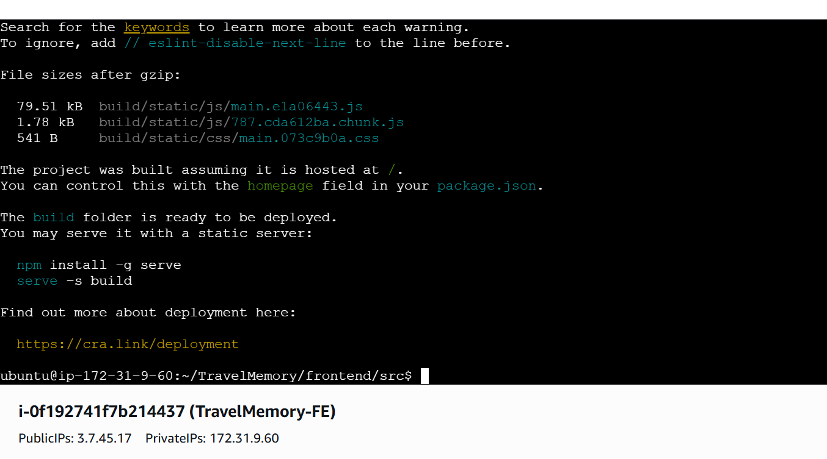
SSL Implementation:
Certbot installation
sudo apt update
sudo apt install snapd

sudo snap install hello-world

sudo apt-get remove certbot

sudo snap install --classic certbot
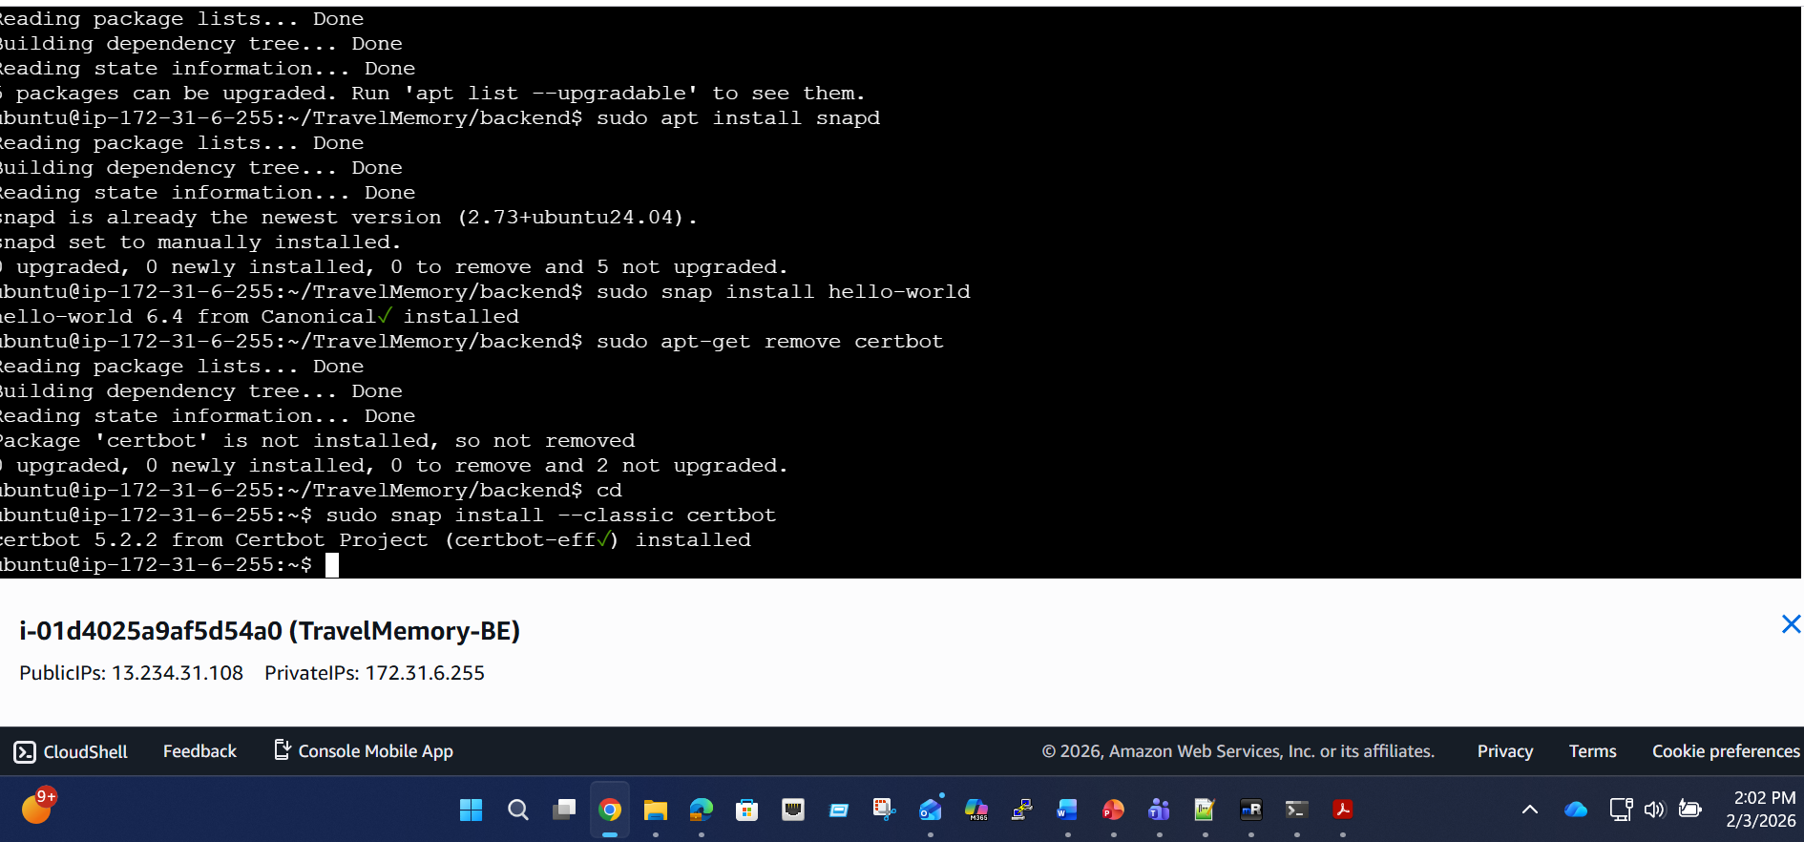


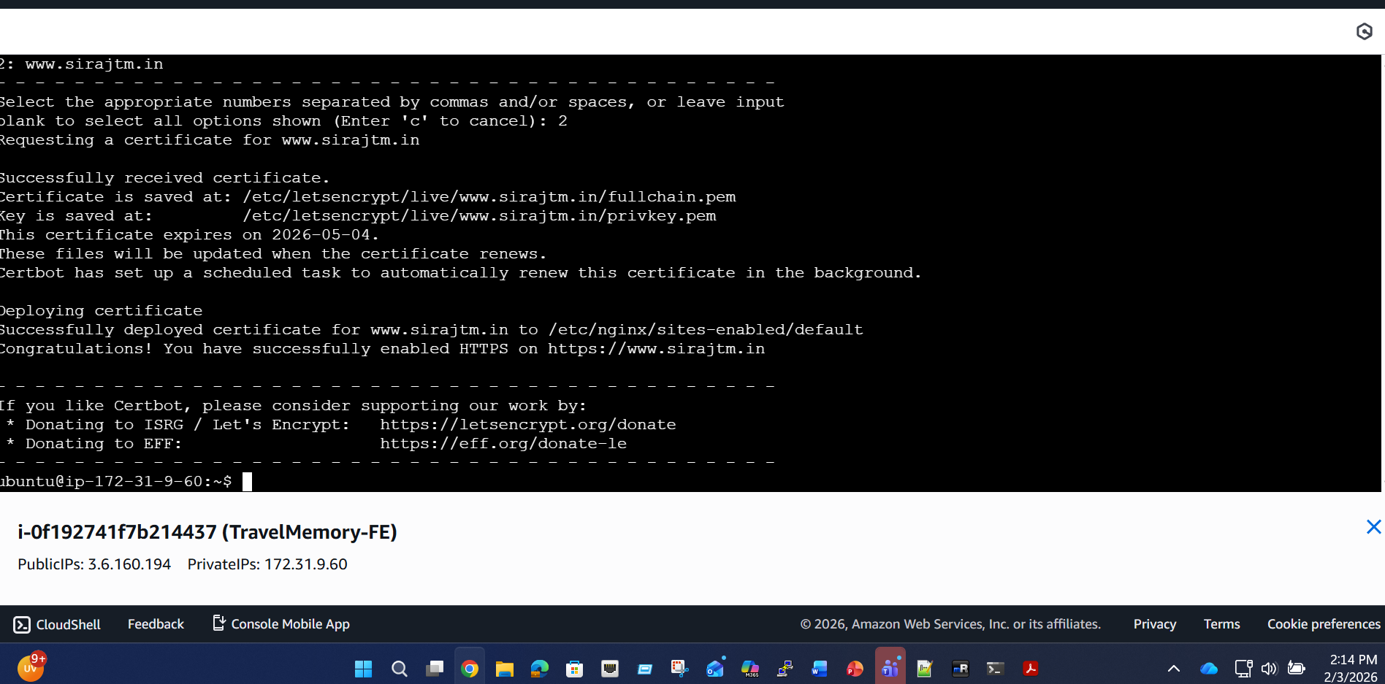

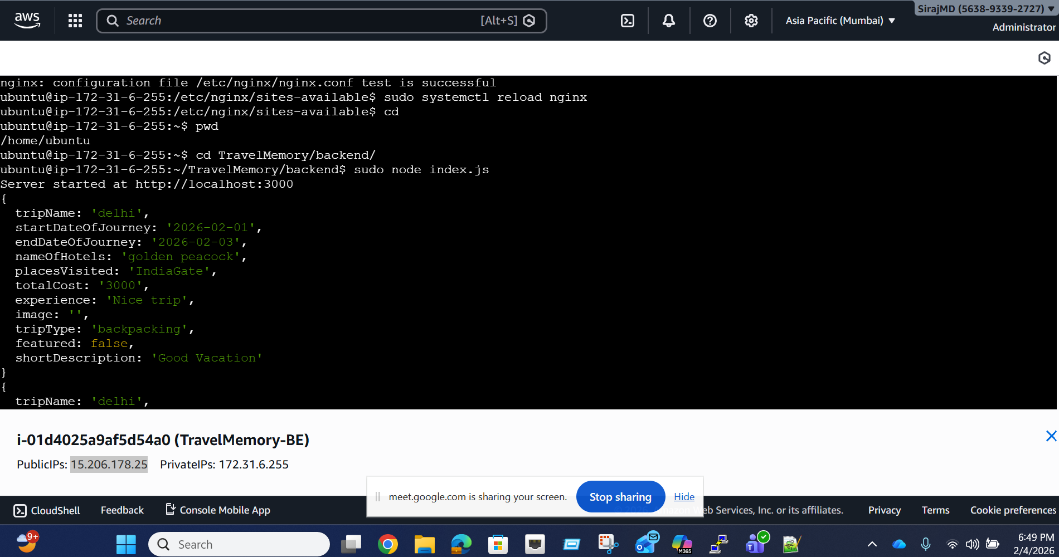

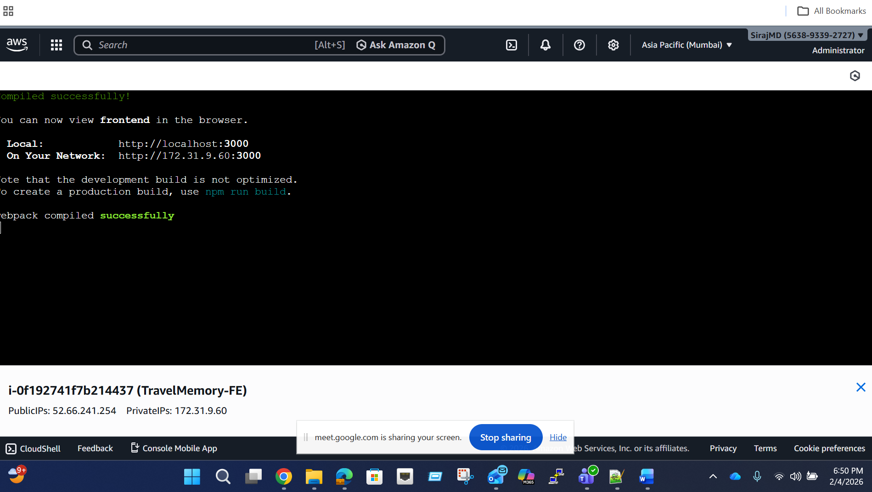

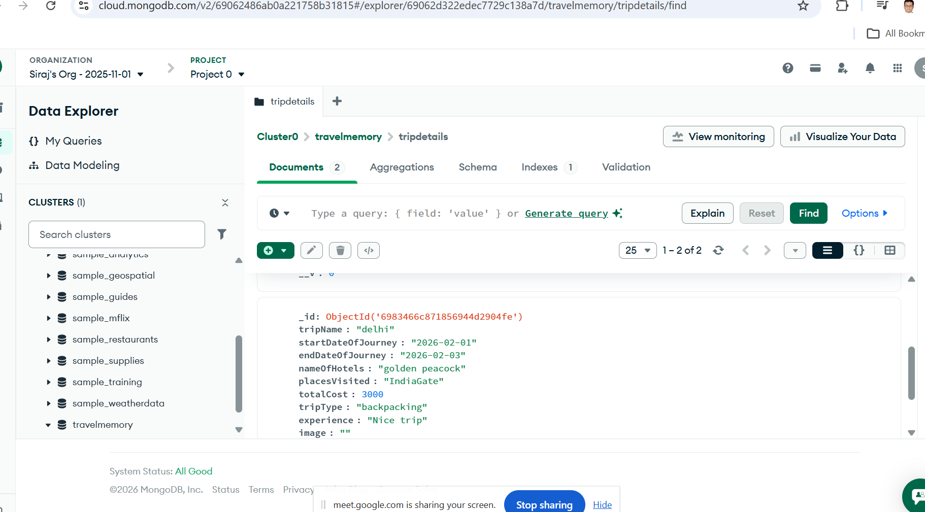

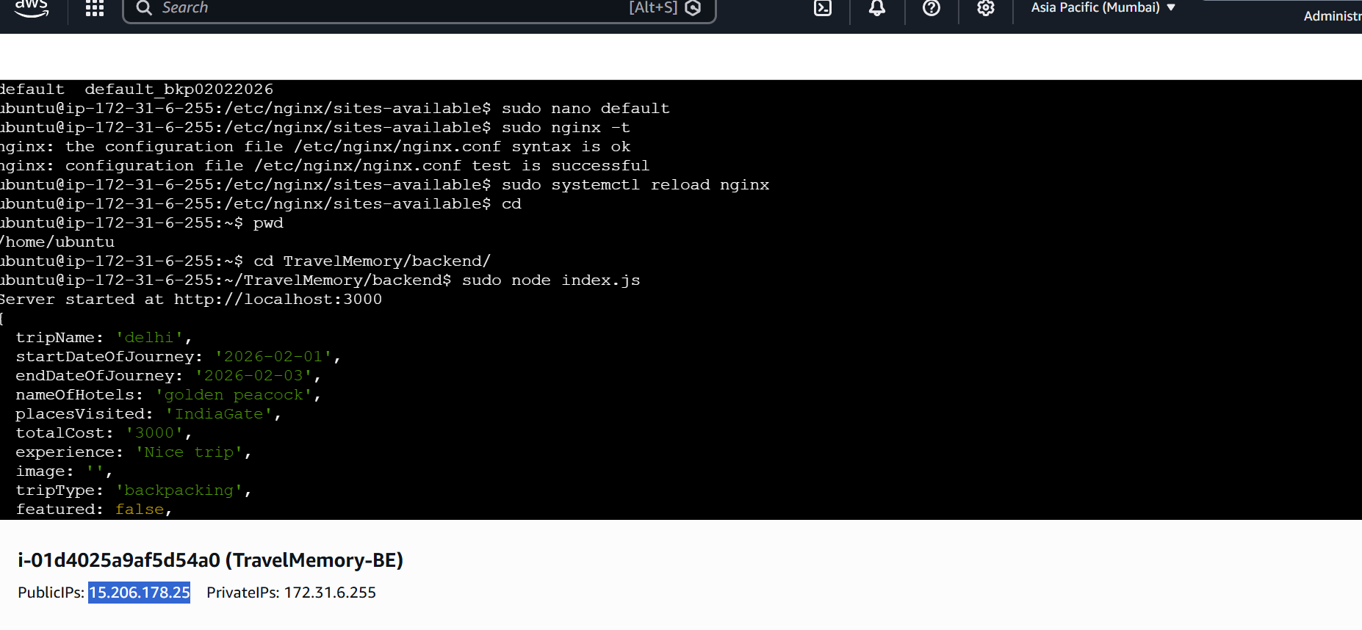

sudo apt update
sudo apt install certbot python3-certbot-nginx -y

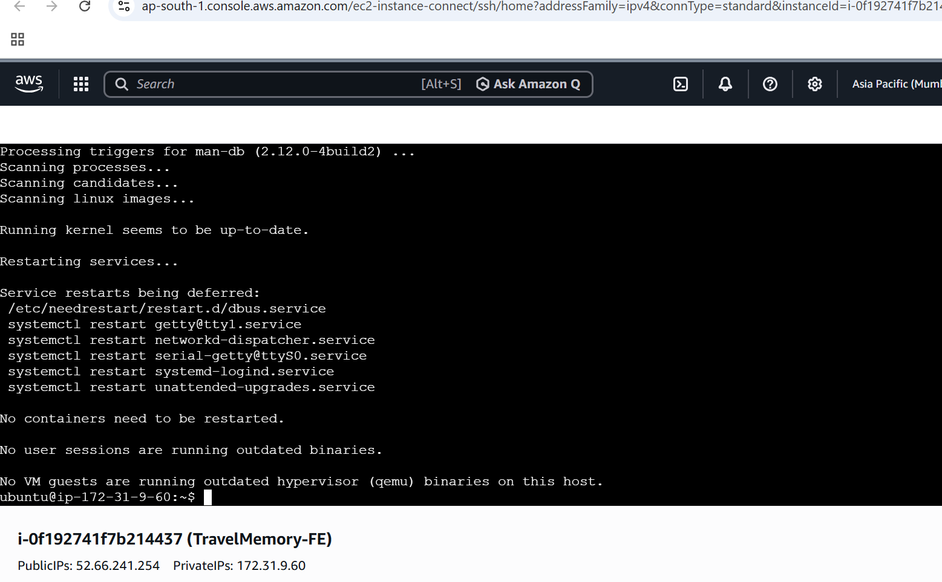
sudo certbot --nginx -d sirajtm.in -d www.sirajtm.in
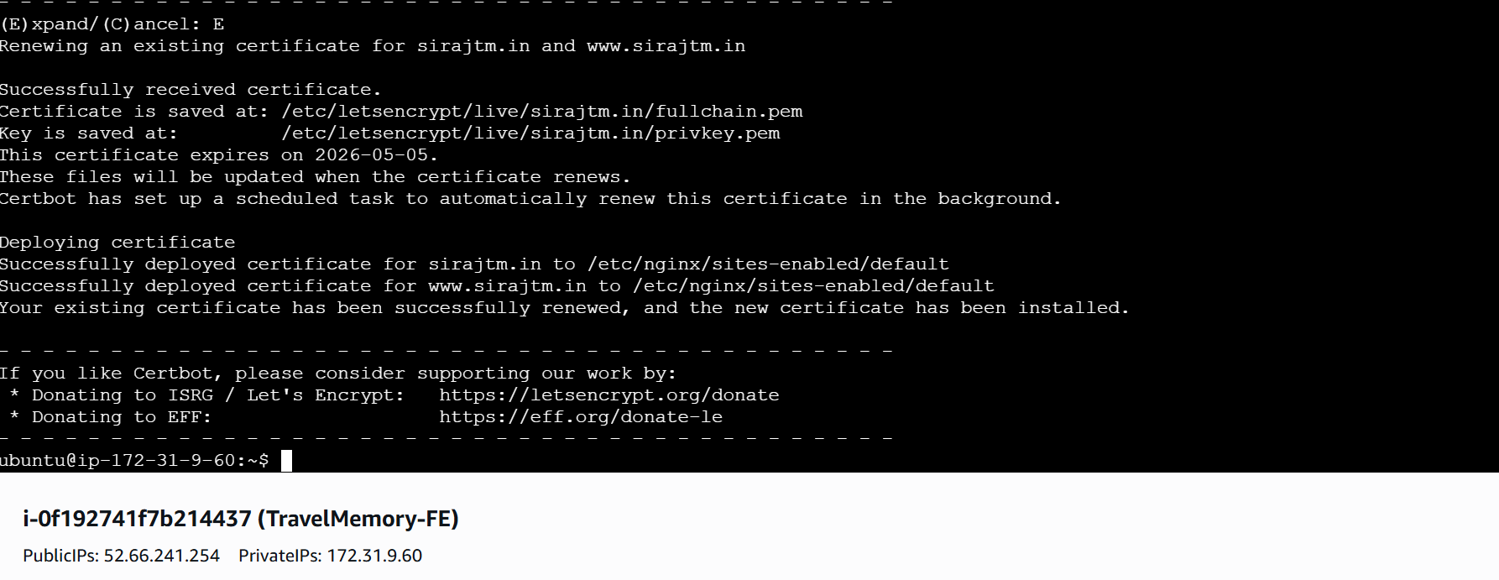

dig +short sirajtm.in
dig +short www.sirajtm.in
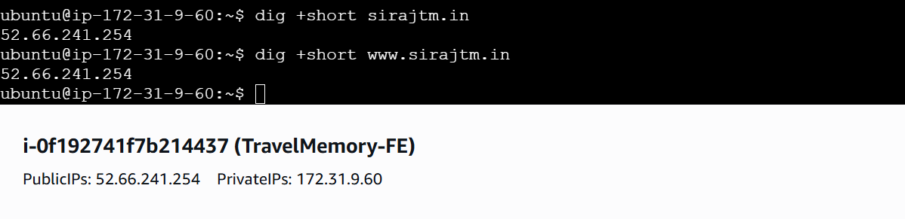

Create an AMI for frontend and backend EC2 instances and then launch an additional EC2 instances from these AMI as shown below
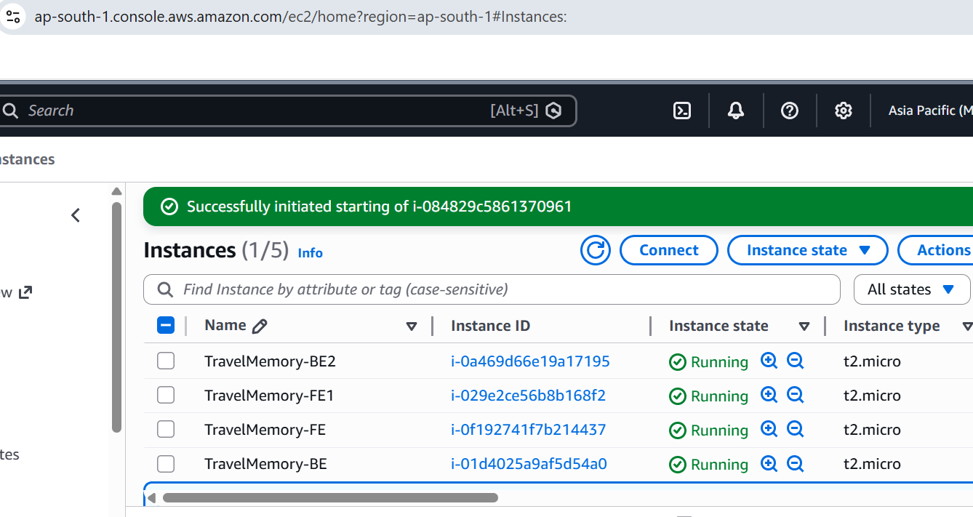

Create Target groups and then register both frontend EC2 instances and backend instances as shown below
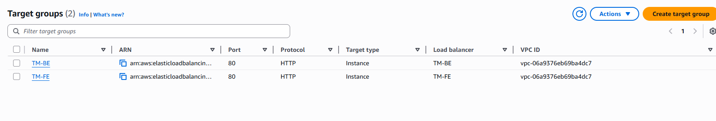

Create load balancers for frontend and backend and attach the respective target groups as shown below
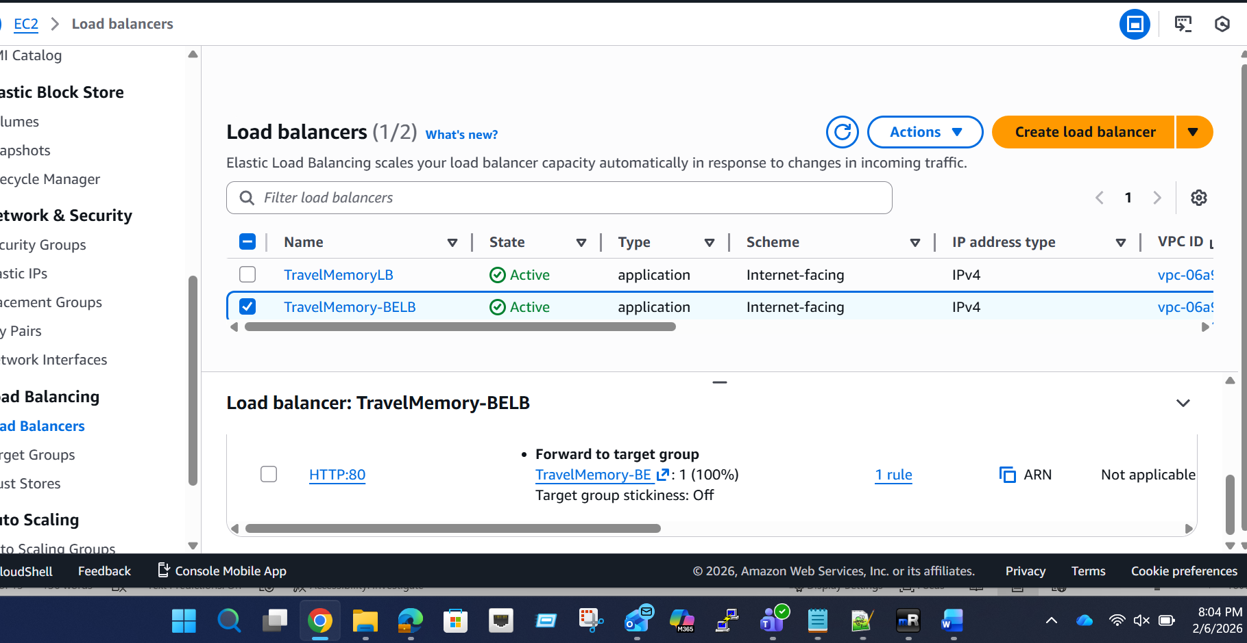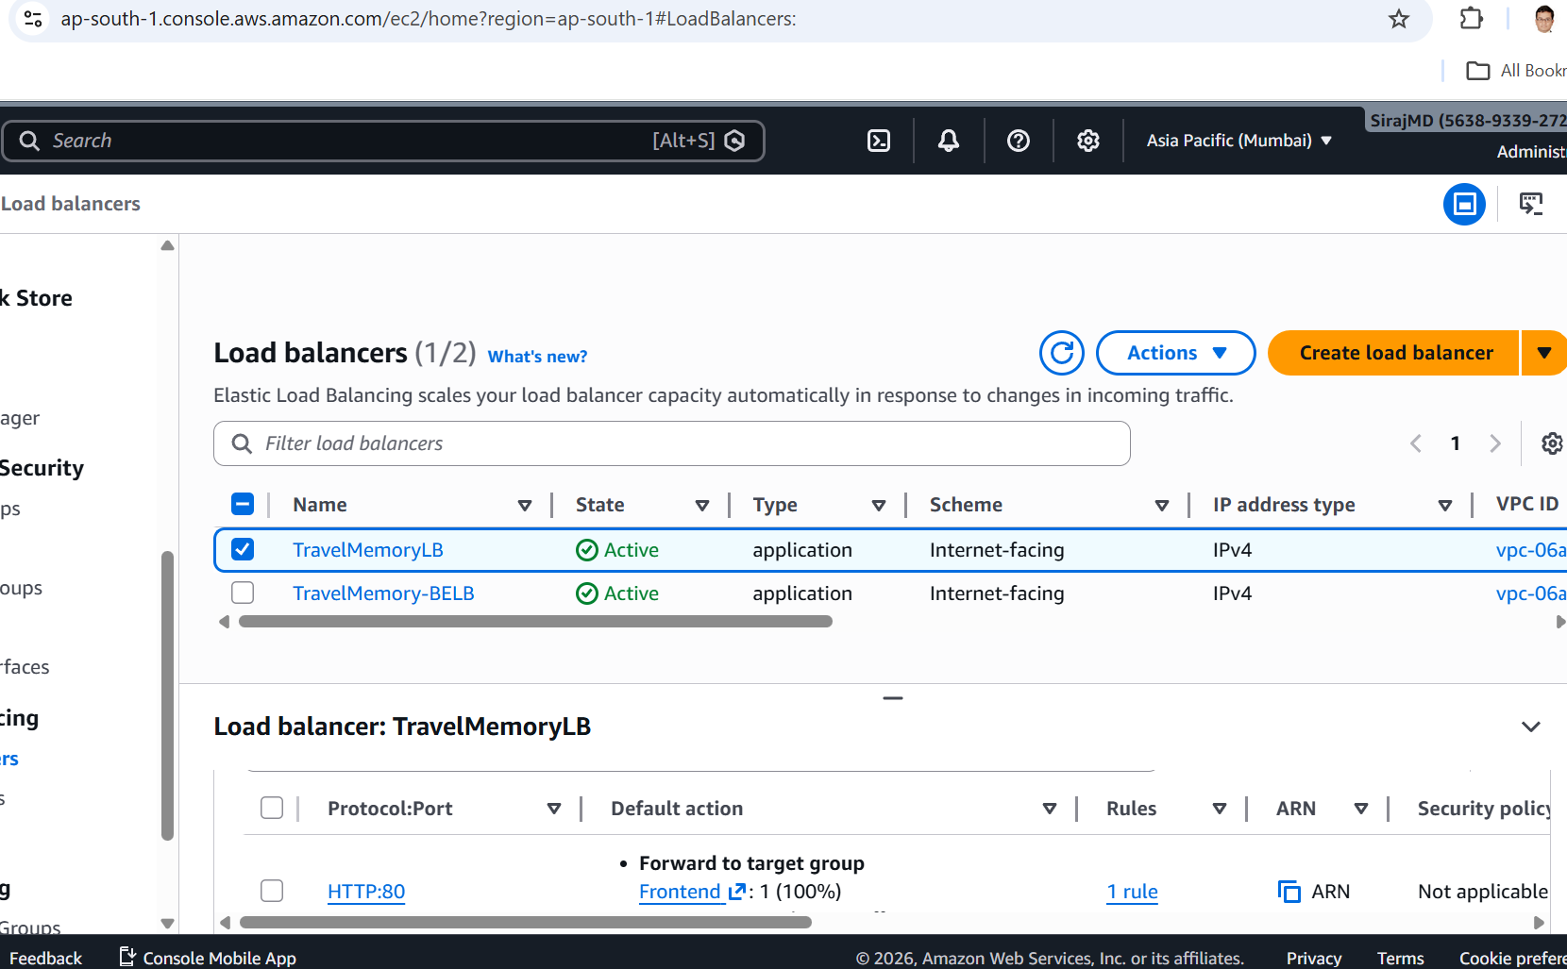
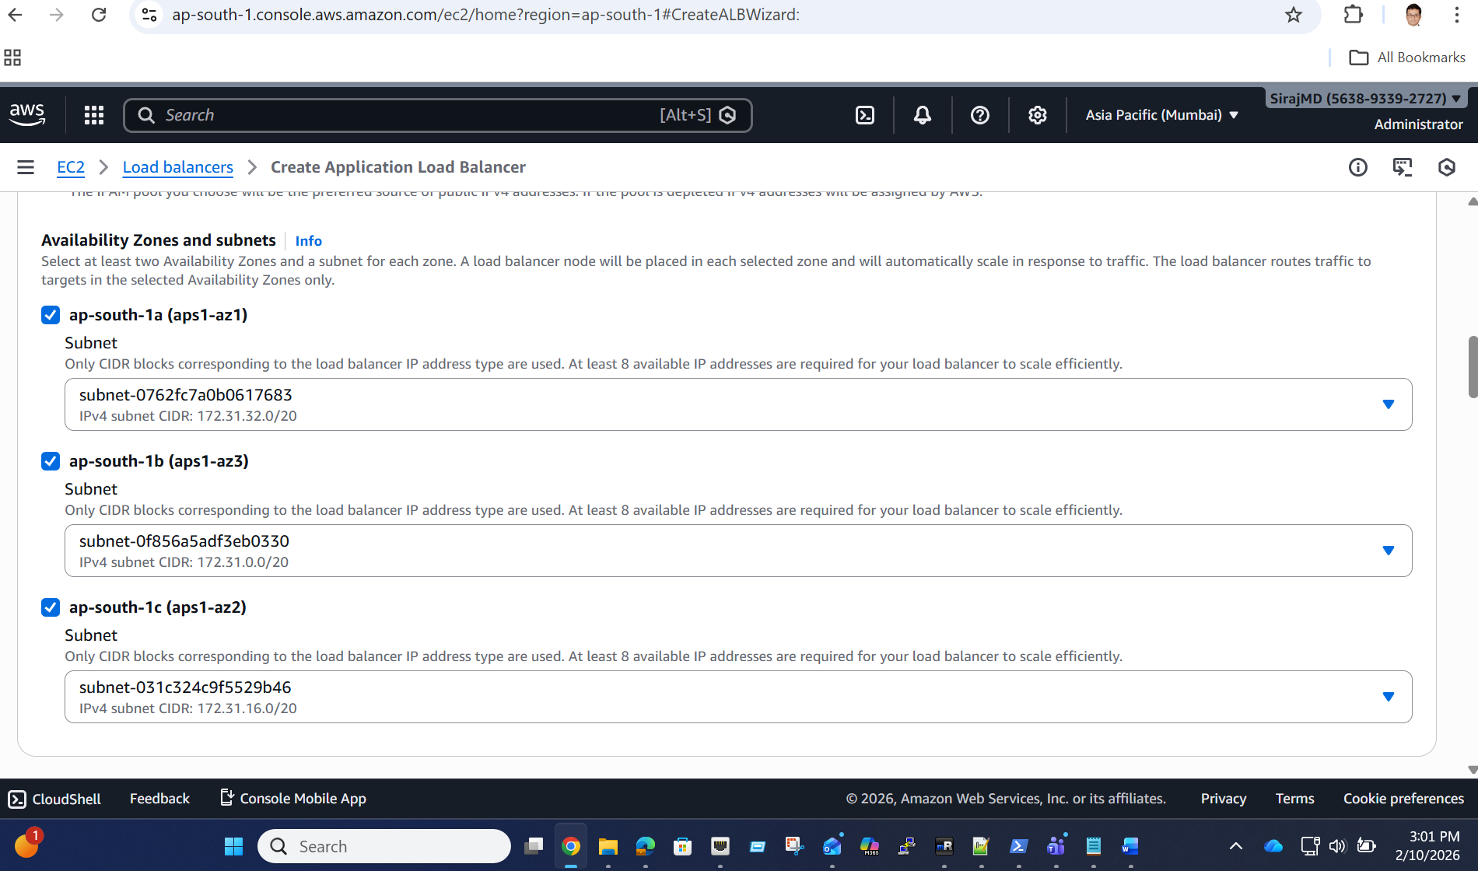

Cloudflare Domain configuration:
In Cloudflare DNS:

1) A Record (Frontend)
- Name: `sirajtm.in`
- Type: `A`
- Value: `<Frontend EC2 Public IP>`

2) CNAME Record (Backend ALB)
- Name: `api`
- Type: `CNAME`
- Value: `<your-alb-dns-name>.elb.amazonaws.com>`

Validation

- Open `http://sirajtm.in` → React UI loads
- Confirm API works:
- Open browser DevTools → Network
- Verify API calls return 200
- In AWS Target Group, confirm all backend instances show Healthy

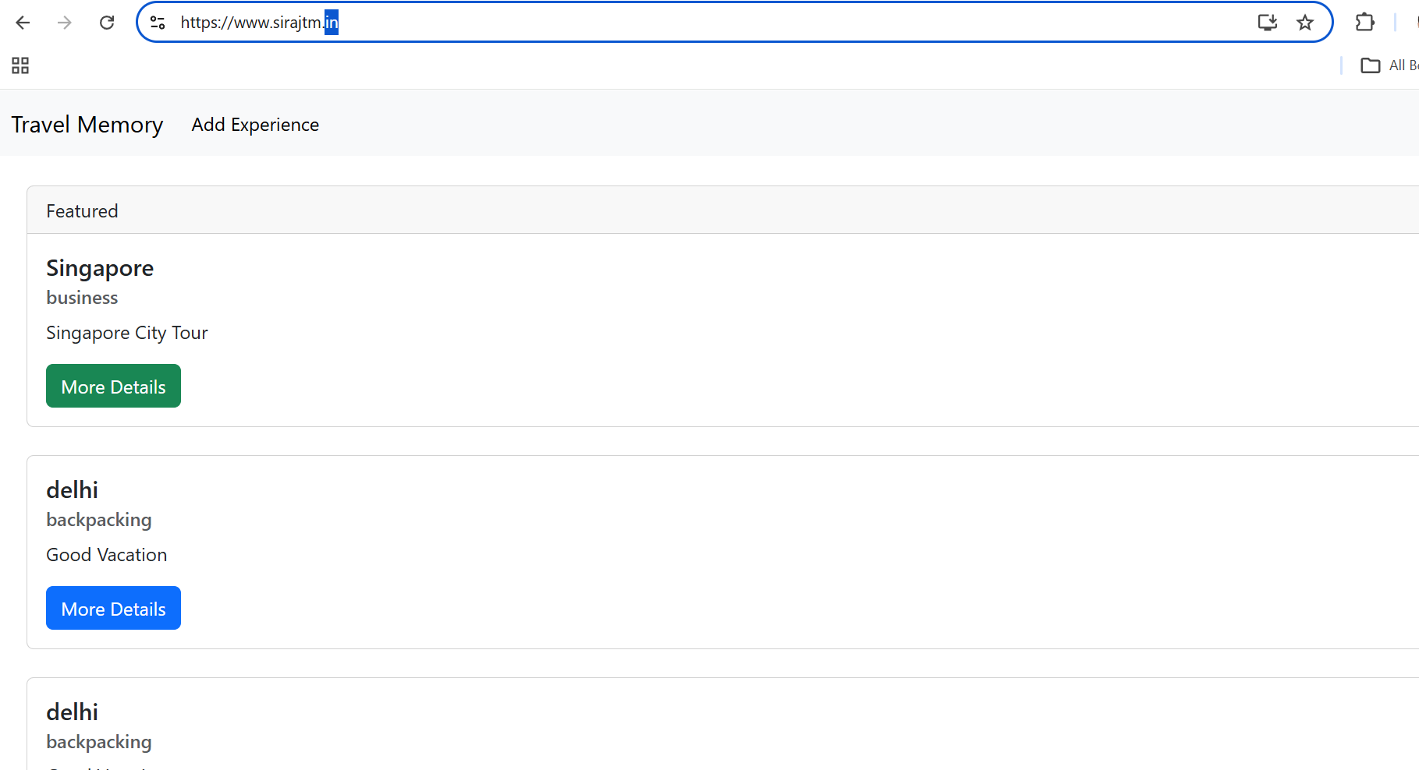

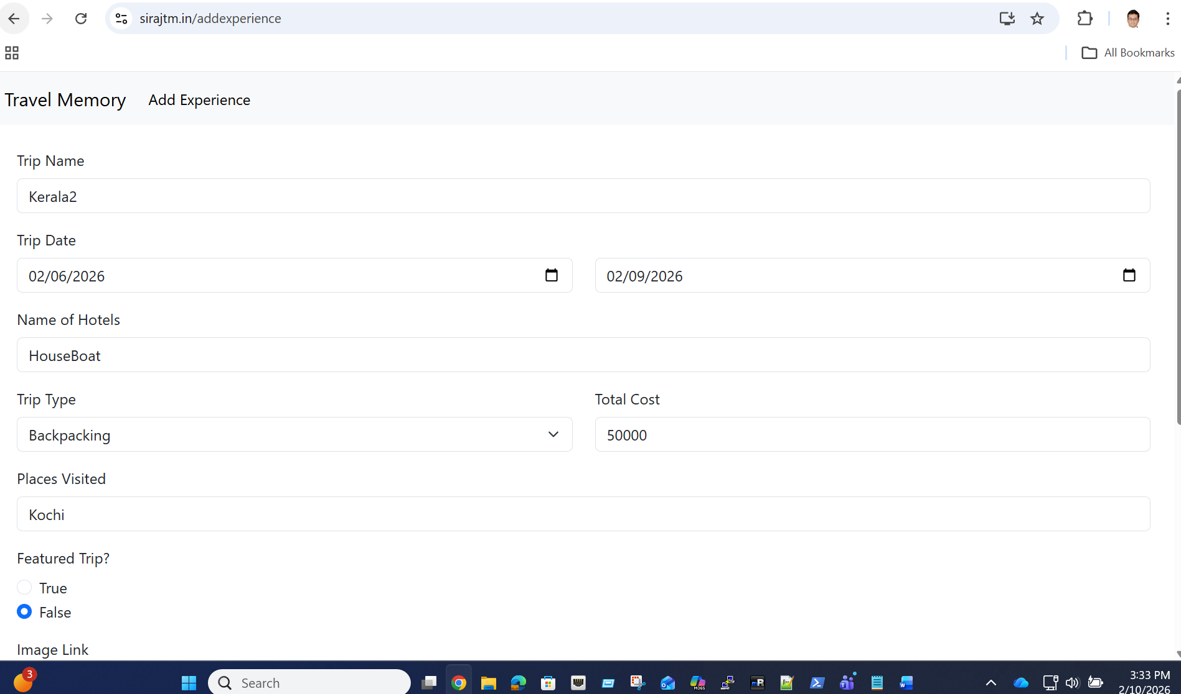
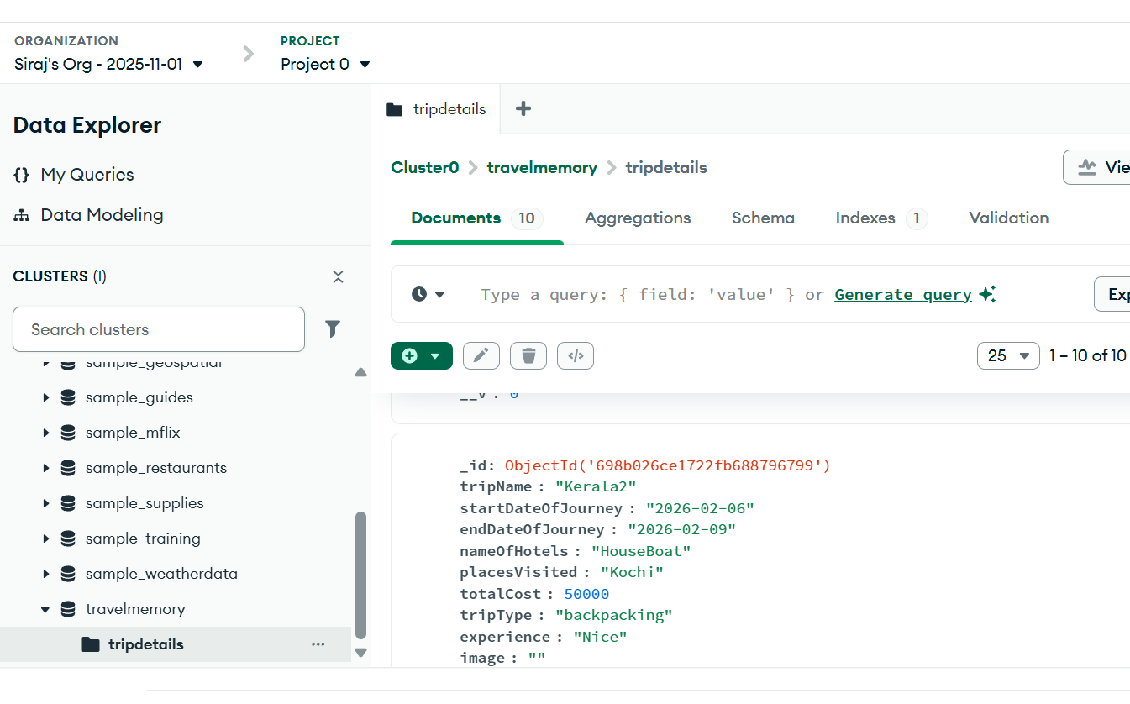
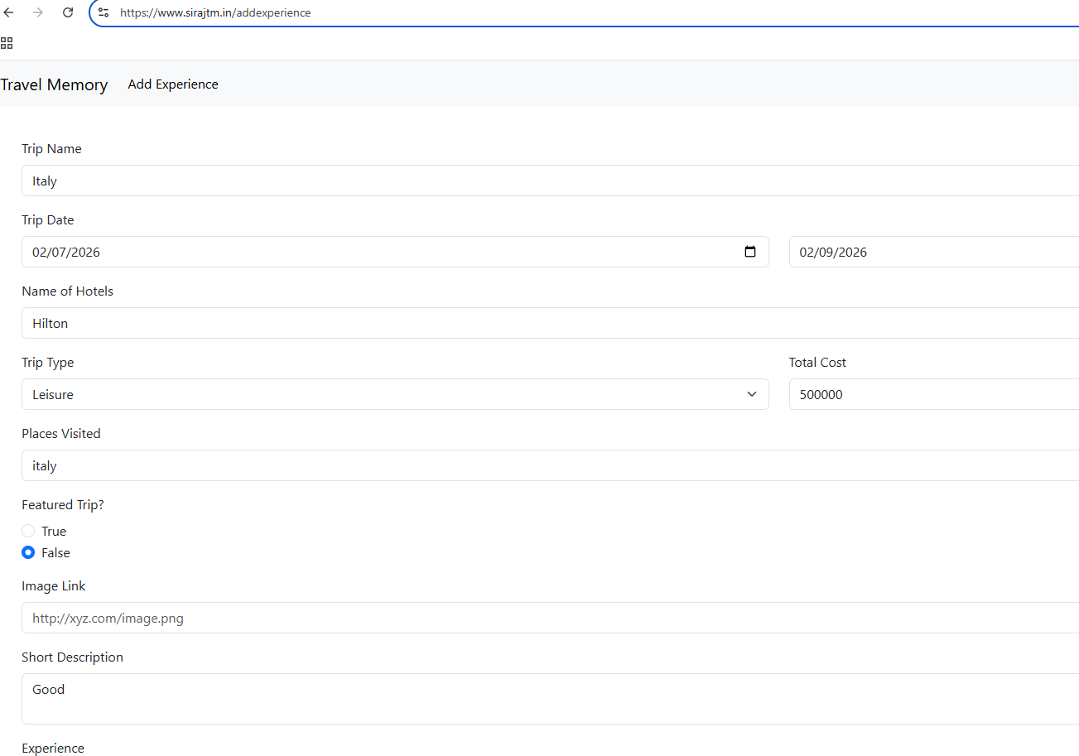
Verify the data is reflecting correctly in MongoDB, below is the screenshot
